This article originally appeared in CXO Magazine, Issue 3, June 2021
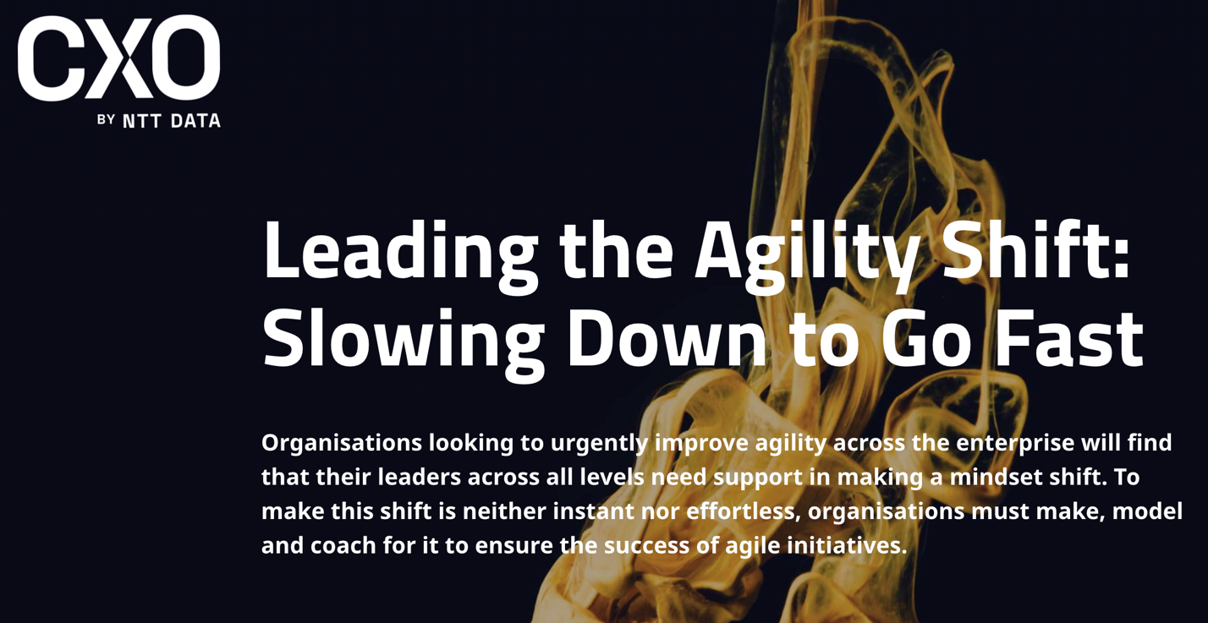
Pamela Meyer, Ph.D.
Leading the Agility Shift: Slowing Down to Go Fast
Organizations looking to urgently improve agility across the enterprise will find that their leaders across all levels need support in making a mindset shift. To make this shift is neither instant nor effortless, organizations must make, model and coach for it to ensure the success of agile initiatives.
The disruptions caused by the global pandemic did not create the need for business agility; they only heightened the urgency for companies that had not yet developed this critical capability.
Organizations that had already prioritized creating a culture and practices in which rapid learning and adaptation could thrive were able to quickly shift to working remotely, while those whose ways of working prioritized planning, control, predictability, and routine struggled to make the shift, slipping behind their peers during the Covid-19 crisis (Handscomb, Mahadevan, Schor, 2020).
Organizations across industries are now urgently working to improve agility across the enterprise. Those seeking to accelerate the process are tempted to approach leading their agility shift as a primarily operational endeavor, restructuring for a flatter, more networked organization, forming cross-functional teams, and often adopting one of many possible agile frameworks. Such enterprise agility efforts are designed to be able to quickly assess and adapt to changes in customer needs, talent requirements, market demand, supply chain disruptions, geopolitical and economic upheaval, and environmental volatility, to name a few.
The agility shift starts with a mindset shift
In their urgency to improve results, leaders often miss the most important aspect of their role: making and modeling an agile mindset shift. The goal of agile structures, systems, and processes is to provide rapid feedback. When leaders receive this feedback without changing their fixed ways of thinking and perceiving, they cannot quickly and effectively learn and adapt, missing out on the value and significant promise of agile and digital transformation.
"The agile mindset shift challenges our very understanding of the function of leadership."
The agile mindset shift challenges our very understanding of the function of leadership. In The Agility Shift, I describe an agile leader as "anyone who effectively responds to the unexpected and unplanned and quickly turns challenges into opportunities." To adopt and lead with this mindset, leaders at all levels of the organization must develop the capability to shift intentionally from being reactive to being responsive.
Slowing Down to go Fast
It takes time and intention to make the shift to an agile mindset. Customer-centric companies with similarly high stakes but operating in industries as widely differing as telecom and pharmaceuticals understood this when they undertook comprehensive, immersive leadership development approaches to improving agility. These initiatives were grounded in leadership development and were separate from the operational mechanics of any specific agile approach, framework, or methodology they would adopt.
T-Mobile invited leaders across the organization to participate in a two-day Agility Shift program based on my work and research. This work was part of an organization-wide imperative to live into its newly adopted brand identity as the "un-carrier" and grow from 33 million customers in 2012 to the fastest-growing telecom company before the merger with Sprint. Today, T-Mobile has grown to more than 102 million customers (Stearns, 2021). The company's ability to pivot was the proudest moment for leadership, as attested by T-Mobile U.S.'s CEO Mike Sievert:
"The ingenuity of our team to complete the largest wireless merger in U.S. history amid an unprecedented global pandemic while continuing to serve customers at a very high level is so inspiring. My biggest accomplishment, actually, all of ours, was to adapt and deliver our best year ever as a team and as a business — and in the middle of a global pandemic."
In the pharmaceutical industry, the customer is ultimately the patient. At Roche, leaders were invited to participate in a similarly immersive, in-house-designed Kinesis leadership program with a primary focus on developing an agile mindset. "A different approach is possible," says Tammy Lowry, head of talent innovation at Roche. "If you invite your senior leaders to show up differently personally and to reimagine how they think about business and organizations, and you are genuine about that and sustain it, it is incredible what can happen."
Shifting to an agile mindset is neither instant nor effortless. Leaders and members of the cross-functional agile teams at UCB, a global biopharmaceutical company, engaged in several activities to develop and sustain this critical mindset shift.
These activities included participating in highly interactive leadership development sessions throughout their agile transformation. Each of these sessions was designed to help team members become more comfortable being uncomfortable and feel more confident communicating, collaborating, and coordinating resources across departmental silos while learning and adapting through iterative cycles of co-creation. This intensive focus on people development is a core foundational focus of UCB's patient value-driven approach to innovation.
"The goal of agile is to provide rapid feedback. When leaders receive this feedback without changing their fixed ways of thinking, they are not able to quickly learn and adapt, missing out on the value and significant promise of agile and digital transformation."
James Hlavenka, then acting as Head of Agility Enablement U.S. Neurology at UCB, shared: "Our commitment to deliver transformational outcomes and experiences for the patients we serve requires us to regularly foster the curiosity and interconnectivity of our people. With an agile mindset, we intentionally prioritize learning and diversity of thought across people and teams, recognizing that both are inextricably linked to our ability to unlock innovative value for our patients."
T-Mobile, Roche, and UCB are not alone in prioritizing an agile mindset shift as part of their overall emphasis on delivering results. The ability to adopt an agile mindset is critical to overall agile success. A joint study by Forbes Insights and the Scrum Alliance of 1,000 C-suite executives across industries found that 83% of respondents cite an agile mindset/flexibility as the most important characteristic of today's C-suite (2018). My research of more than 1,500 leaders across industries found a strong link between an agile mindset and overall agility; there is an especially strong link between mindset and the capability to be responsive and resourceful (Meyer, 2019).
Translating agile leadership mindset into action
The value of providing time and support for leaders to develop an agile mindset is borne out by T-Mobile's sustained growth and its rigorous Agility Shift Impact Study.
Their analysis found that 78% of leaders could point to tangible business results from applying their new learning (Lanier Preston, 2019). Slowing down to go fast does not have to mean delaying results. It means being intentional and providing the resources and development pathways that set your leaders up for success.
"Slowing down to go fast does not have to mean delaying results. It means being intentional and providing the resources and development pathways that set your leaders up for success."
At UCB, the impact is both measurable and striking for patients and the organization alike. Within the first nine months of the transformation, the UCB team reduced errors and realized resource efficiencies, cutting average development cycles by 26% and increasing market-readiness by 25%.
This translated to an organizational capacity to become even more responsive to the needs of the patients they serve. Moreover, team members remarked how this new way of working positively impacted their team culture and productivity, self-reporting a 75% increase in favorability scores for clarity in communication and effective decision-making (UCB, 2019).
"By embracing an agile mindset that prioritizes learning, team members intentionally upskilled one another outside areas of core competencies to enhance their collective team knowledge and ability to work together, better equipping the whole to leverage diverse talents and perspectives to rapidly deliver innovative value to our patients," said UCB's Hlavenka.
Leading the agility shift in your organization means making, modeling, and coaching for the mindset shift and behavior to ensure the success of your agile initiatives. As countries, industries, and customers emerge from the pandemic, practices that help leaders sustain an agile mindset will be more critical than ever. The very human temptation to return to normalcy invites a return to familiar thinking habits, attitudes, and behaviors that favor planning.
References

Ewenstein,B. Smith, W., and Sologar, A. (2015). Changing change management. McKinsey: https://www.mckinsey.com/featured-insights/leadership/changing-change-management#:~:text=Change%20management%20as%20it%20is,percent%20more%20likely%20to%20stick.

Forbes Insights and Scrum Alliance. (2018) The Elusive Agile Enterprise, joint study by Forbes Insights and the Scrum Alliance. Global survey of 1,000 C-suite executives across industries.

Handscomb, C., Mahadevan, D., Schor, L., Sieberer, M., Naidoo, E. & Srinivasan, S. (2020) An operating model for the next normal: Lessons from agile organizations in the crisis. McKinsey: (https://www.mckinsey.com/business-functions/organization/our-insights/an-operating-model-for-the-next-normal-lessons-from-agile-organizations-in-the-crisis).

Lanier Preston, M. (2019) The Agility Shift: T-Mobile develops leaders for a VUCA World [Powerpoint slides] SlideShare.

Lurie, M. (2019). How a healthcare company is pursuing agile transformation. McKinsey: https://www.mckinsey.com/business-functions/organization/our-insights/how-a-healthcare-company-is-pursuing-agile-transformation

Meyer, P. (2019) New year, new agile mindset. [Blog post] https://pamela-meyer.com/new-year-new-agile-mindset/

Rigby, D. K., Sutherland, J., Takeuchi, H. (2016) Embracing agile: How to master the process that’s transforming management. Harvard Business Review: https://hbr.org/2016/05/embracing-agile

Sterns, J. (2021). The new Mr. Magenta. 425Business: https://425business.com/the-new-mr-magenta/

UCB (2019). Internal data analysis and report.

